* 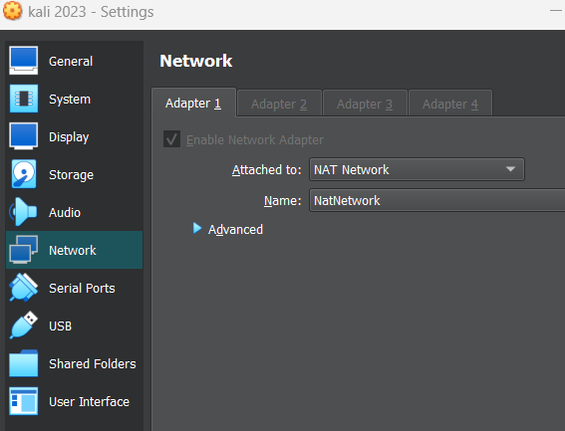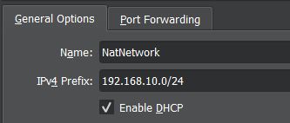Create a Metasploitable 2 Virtual Machine in a NAT Network environment.
* Using Kali, scan and enumerate on Metasploitable 2 VM.

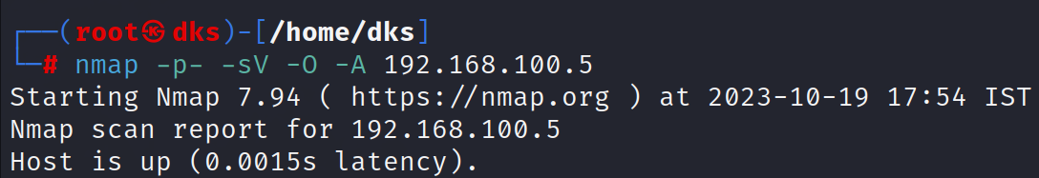

* Do a default scanning on Metasploitable 2 VM.

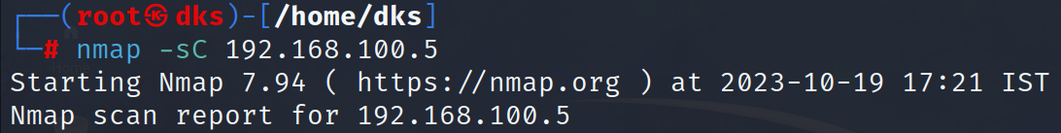

* Perform brute force password auditing against FTP service in Metasploitable 2 VM.

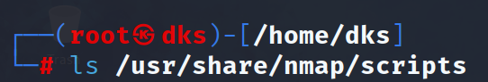

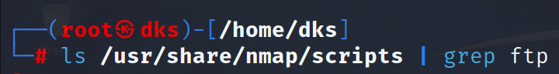

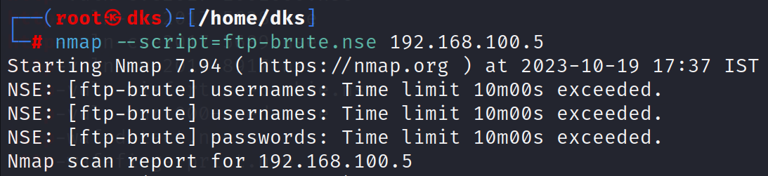

* 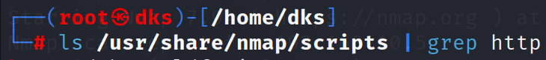Find the script's name that checks for the remote code execution vulnerability MS15–034 (CVE2015–2015–1635)?

